Digital Twin Infrastructure Architecture – Complete Data Flow Documentation

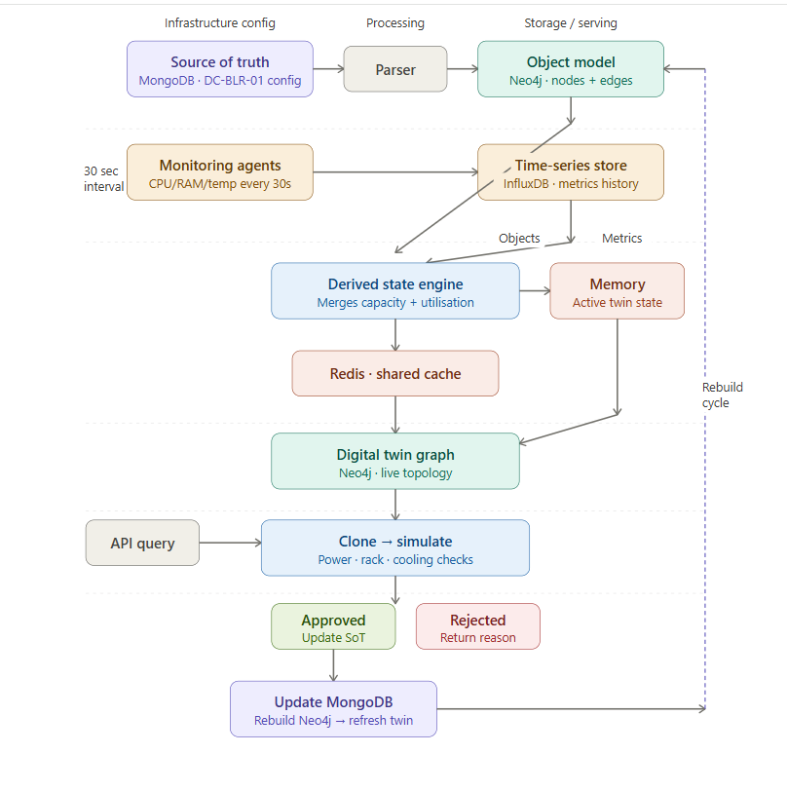

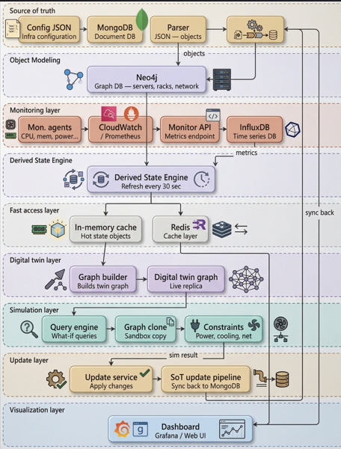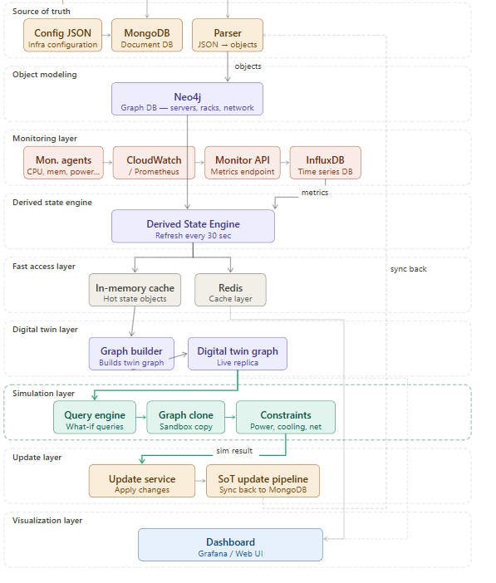
1. Overview
The system builds a Digital Twin of private cloud infrastructure by combining static configuration (Source of Truth) with dynamic monitoring telemetry. The twin enables real-time infrastructure visibility and what-if simulations before applying changes.
The system consists of:
- Source of Truth Layer
- Object Modeling Layer
- Monitoring Layer
- Derived State Engine
- Digital Twin Graph
- Simulation Engine
- Update Pipeline

2. Source of Truth Layer (Infrastructure Configuration)
Purpose
Stores static infrastructure configuration which represents the desired state of infrastructure.
This includes:
- Servers
- Racks
- Storage
- Network topology
- Capacity limits
Storage
Database used:
MongoDB (Document DB)
Reason:
- Stores JSON natively
- Easy updates
- Version tracking
Sample Source of Truth JSON
Example infrastructure configuration:
{
"datacenter":"DC1",
"racks":[
{
"rack_id":"R12",
"total_units":42,
"power_capacity_kw":8
}
],
"servers":[
{
"server_id":"SRV101",
"cpu_cores":32,
"ram_gb":128,
"storage_tb":4,
"rack":"R12",
"power_kw":0.7
}
]
}
Update Frequency
Source of Truth updates only when:
- Server added
- VM created
- Storage expanded
- Network changed
Typical frequency:
Event based (not periodic)

3. Object Modeling Layer
Purpose
Convert JSON into structured infrastructure objects.
Example object:
Server Object
Server ID : SRV101
CPU : 32 cores
RAM : 128GB
Rack : R12
Power : 0.7KW
Storage
Recommended DB:
Neo4j Graph Database
Reason:
Digital twin requires relationship queries.
Example relationships:
Rack R12 → CONTAINS → Server SRV101
Server SRV101 → CONNECTS → Switch SW1
Server SRV101 → USES → Storage POOL1

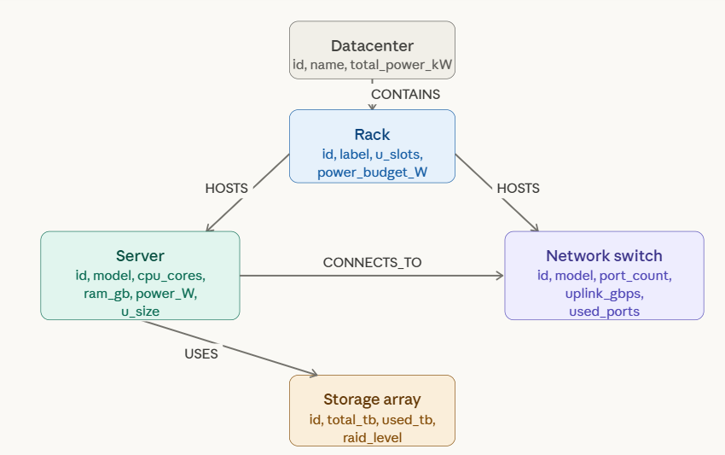
Sample Graph Data Representation
Nodes:
Rack:
ID: R12
Capacity: 42U
Server:
ID: SRV101
CPU:32
RAM:128
Edges:
(R12) ----contains----> (SRV101)
(SRV101) ----uses----> (POOL1)
Update Frequency
Only when Source of Truth changes.

4. Monitoring Layer
Purpose
Collect real-time infrastructure telemetry representing the observed state.
Metrics collected:
Compute:
- CPU usage
- Memory usage
- Disk usage
Infrastructure:
- Power usage
- Temperature
Network:
- Bandwidth usage
- Port utilization
Health:
- Status
- Alerts
Storage
Recommended:
InfluxDB (Time Series DB)
Reason:
Optimized for time-based data.
Monitoring Collection Interval
Recommended:
30 seconds
Example:
Metric | Interval
CPU | 30 sec
Memory | 30 sec
Network | 30 sec
Temperature | 30 sec

Sample Monitoring Data
Example monitoring record:
{
"server_id":"SRV101",
"cpu_usage":72,
"memory_used":90,
"memory_total":128,
"temperature":38,
"power_usage":0.65,
"timestamp":"21:30"
}
Stored in InfluxDB as:
measurement: server_metrics
tags:
server_id=SRV101
fields:
cpu_usage=72
memory_used=90
temperature=38
timestamp:
2026-03-23 21:30:00

5. Derived State Engine
Purpose
Combine:
Infrastructure objects
+
Latest monitoring metrics
To create:
Current infrastructure state
Formula
Derived State:
Derived State =
Configuration Capacity
+
Runtime Utilization
+
Health Indicators
Sample Derived State
Object:
Server SRV101
Capacity:
CPU:32
RAM:128GB
Power:0.7KW
Monitoring:
CPU usage:72%
RAM used:90GB
Power used:0.65KW
Temperature:38C
Derived:
Server SRV101
Capacity:
CPU:32
RAM:128
Usage:
CPU:72%
RAM:90GB
Derived:
CPU free:28%
RAM free:38GB
Power free:0.05KW
Health:
Healthy
Derived State Generation Interval
Recommended approach:
Hybrid strategy:
Generate:
- Every 30 seconds
- On new monitoring arrival
- On query if stale
This ensures accuracy.

6. Derived State Storage
Derived state must be extremely fast to access.
Primary storage:
In-memory storage
Example:
ActiveTwinState Map
SRV101:
CPU_free=28%
RAM_free=38GB
Status=Healthy
Secondary storage:
Redis
Reason:
- Fast reads
- Distributed access
- Persistence option
Example Redis entry:
Key:
server:SRV101
Value:
{
"cpu_free":28,
"ram_free":38,
"status":"healthy"
}
Optional ML Storage
Historical derived states stored in:
MongoDB
Used for:
- Trend analysis
- ML training
- Prediction models

7. Digital Twin Graph Creation
Purpose
Build real-time infrastructure graph from derived state.
Graph contains:
Nodes:
Datacenter
Rack
Server
Switch
Storage
Edges:
CONTAINS
CONNECTS_TO
USES
HOSTS
Example Graph
Nodes:
Rack R12
Server SRV101
Switch SW1
Storage POOL1
Edges:
R12 → CONTAINS → SRV101
SRV101 → CONNECTS → SW1
SRV101 → USES → POOL1
Graph stored in:
Neo4j
Update interval:
Every derived state refresh:
30 seconds

8. Query and Simulation Flow
Example query:
Can I add 4 servers to Rack R12?
Flow:
Query arrives
↓
Load latest derived state (memory)
↓
Build graph
↓
Clone graph
↓
Apply proposed change
↓
Run constraint validation
Constraints checked:
- Rack capacity
- Power limits
- Cooling capacity
- Network ports
- Storage availability

Simulation Example
Before:
Rack R12:
Capacity:42U
Used:38U
Available:4U
Add 4 servers:
Needed:4U
Available:4U
Result: PASS
Power check:
Capacity:8KW
Used:7KW
New servers:0.8KW
Total:7.8KW
Result: PASS
Simulation Result:
Change Approved

9. Infrastructure Update Flow
If simulation passes:
System updates infrastructure.
Flow:
Simulation approved
↓
Update Source of Truth
↓
MongoDB updated
↓
Objects rebuilt
↓
Neo4j updated
↓
Next monitoring refresh updates twin
Example Source of Truth update
Before:
"servers":[SRV101,SRV102]
After:
"servers":[SRV101,SRV102,SRV103]

10. Timing Summary
Component | Interval
Monitoring collection | 30 sec
Derived state update | 30 sec
Graph refresh | 30 sec
Simulation | On query
Source of Truth update | On change
Redis update | On derived update

11. Database Summary
Data Type | Database
Source of Truth | MongoDB
Infrastructure objects | Neo4j
Monitoring data | InfluxDB
Derived state | Memory + Redis
ML history | MongoDB
Digital twin graph | Neo4j

12. Complete End-to-End Flow
Final architecture:
Source of Truth (MongoDB)
↓
Parser Service
↓
Infrastructure Objects (Neo4j)
Monitoring Agents
↓
Metrics Collection
↓
InfluxDB
Objects + Metrics
↓
Derived State Engine
↓
Stored in:
Memory
Redis
↓
Digital Twin Graph
↓
Query arrives
↓
Graph cloned
↓
Simulation executed
If approved:
Update Source of Truth
Rebuild objects
Refresh twin

